**Stealing a Boeing 747-8**

**Plot**

It appeared to be a normal day for Ralph, was flying from Aden Adde International

Airport in Somalia back to his home in Toronto at the Pearson International Airport. The landing was smooth and there were no problems at security or customs, Ralph went to enter into his taxi to return home to his apartment. Before he could tell the driver his address, the driver sped off, clearly upset Ralph was yelling at the man but when he went to take out his phone the driver yelled at him with a strong Somali accent. The driver said “Put the phone down, I have a proposal for you, if you wish to survive the night you will call me at this phone number.” Ralph was very confused however he went along in fear of his life, the driver drove him home and Ralph exited the cab and went into his apartment.

He called the phone number and the same voice responded on the line, he said “My name

is Jack, I am giving you the opportunity to make 33% of a $150 million pot.” As Jack briefed the plan to Ralph, he became more and more convinced about this plan. Ralph accepted the proposal but asked for one condition “there shall be no threat or action of violence”. Jack accepted these terms and told Ralph that his plan would begin on Tuesday December 12. Ralph would take a two week vacation and a body double who would be payed $500,000 would travel to Istanbul and stay there until he met with Ralph.

Ralph would head to a hotel room on Monday December 11th where he would meet Jack

and they would discuss the details of the plan. Jack is an experienced criminal and has connections to possible buyers for a Boeing 747-8 and connections to officials in the government. Jack is also very skilled and knowledgeable in money laundering, fencing and tax evasion. In the hotel room Ralph would meet Ahmed, the second accomplice to this crime. Ahmed is an electronics genius and is important to the plan so will also receive a 33% share of the winnings. Ahmed 8 months ago got a job as a Turkish Airlines flight attendant where he was provided with 5 uniforms, one for each day of the week. Ahmed two months ago quit his job but kept his uniforms. Ahmed’s identity was protected due to him applying for the job under a false identity and by wearing a hat when working to prevent cameras from identifying him.

Ralph will enter the airport at 8:30AM EST and Jack will enter the airport at 9:30 AM

EST where they will buy two different plane tickets out of Toronto to prevent suspicion. Ahmed will enter at 10:00AM EST and buy a ticket out of Toronto as well. Jack and Ralph will then go through security with their bags that contain nothing but two Turkish airlines uniforms and a satellite phone. Ahmed will have his brief case which contains a radio kit and one DJI phantom 4 quadcopter controller. Once through security they will go through customs where they will claim that they are visiting family and will use their false passports. Once through customs Ralph goes to the washroom where he changes into the Turkish Airlines uniform and 30 minutes later Jack does the same thing. Before the plane lands, Ralph will plant a note on the gate’s entrance desk that will tell the members to let them onto the plane to help clean because the inspector is appearing at 11:00AM, the plane should be ready for takeoff. When the plane from Istanbul lands in Toronto, Ralph and Jack will claim that they are new to Turkish Airlines and have been told to help clean the plane. If the gate attendant decides to ask their superiors, Ahmed will be on the radio frequency on which they communicate and will tell the other flight attendants that they are in training and to allow them to clean the plane and that the inspector is on his way.

Once on the plane, Ralph and Jack will clean the plane, before everyone leaves the plane, they say that they need to do more cleaning. Ahmed will then approach the desk and claim that he is the inspector. He will show his ID card to the front desk and will tell them he will be analyzing the plane alone. He will say he will be doing diagnostic tests and not to be alarmed.

The ID card was obtained 3 months prior to the commission of this crime, Ralph was inspected by a man named Charles Edward. Jack followed Charles home after his work and took pictures of the exterior of his house at night. 15 days later while Charles was out for dinner, Jack picked the lock to Charles’ room and entered it, Jack put on a hair net and wore bags on his shoes to cover up any evidence. Jack then searched his house and found in his jacket his id card which he picked up using gloves to prevent finger prints. Jack took a picture of Charles’ ID card and left the house. Jack then got Ahmed to recreate Charles’ ID card and replace the photo with Ahmed’s in Photoshop. The new ID card was then printed and laminated to the specifications required.

Ahmed will then board the plane where he will meet Jack and Ralph. Since the employees were told to ready the plane, it will be fueled and they have the ability to takeoff. But there is the issue of the air traffic control tower may become aware of them leaving without permission, so Ahmed will use the DJI remote control to control the quadcopter he placed in the field near the airport. Ahmed will move the quadcopter onto the runway which will cause air traffic control to order all planes to leave the airspace to prevent an accident. During this commotion Ralph will turn off all external communications including the transponder and lights and will taxi out of the gate. He will liftoff on one of the runways and will fly east towards the Atlantic Ocean. The Boeing 747-8 is then flown to Syria where it is sold to the Syrian government for a discounted price of $150 million down from the market price of ~$380 million.

One issue with this plan though is the government will be searching for this plane. Once it has landed in Syria it will be fully repainted and the Syrian government will replace much of the electronics to prevent suspicion if the plane is searched. Five days after the plane has departed part of the plane’s old electronics will be placed on a beach in Portugal where it will be discovered by the police and will cause the government to suspect the plane crash landed in the Atlantic Ocean.

Ralph will meet with the body double where he will get his passport back so he can return to Toronto, the body double will stay and live in Istanbul.

The $100 million is then put into multiple Swiss and offshore bank accounts which guarantee confidentiality to their clients. They then spend $5 million to setup 3 different businesses, a farm in Saskatchewan, a real estate business in British Columbia and a car wash in Ontario. These businesses all have employees and appear to be normal businesses. The farm and car wash both act as normal businesses but on top of their normal revenue a significant amount of money is funneled from the banks into the business which records the money as income from cash paying consumers.

The real estate company is in British Columbia because British Columbia has high property values so a sale with an exchange of over $1 million would not be a surprise to auditors. The farm is in Saskatchewan because Saskatchewan gives significant subsidies to farms which can mean even more profit for the company. The car wash is in Ontario because Ontario has the highest amount of new cars sold which means that a lot of money can be funneled into the business without people wondering. The businesses are effective but the real estate business is more profitable. The real estate business buys up property using money from the bank accounts and then sells these properties to consumers. All business related to these properties are handled through the realty company to minimize problems when dealing with these properties in respect to the type of payment and the origin of the money.

**Research**

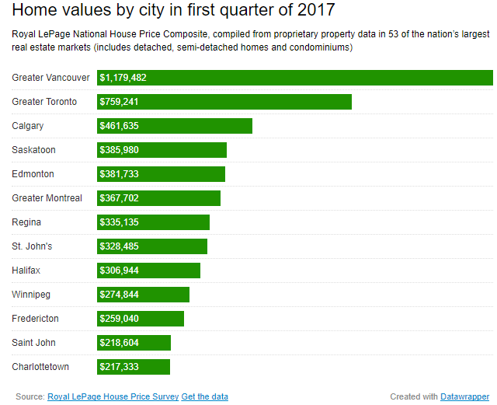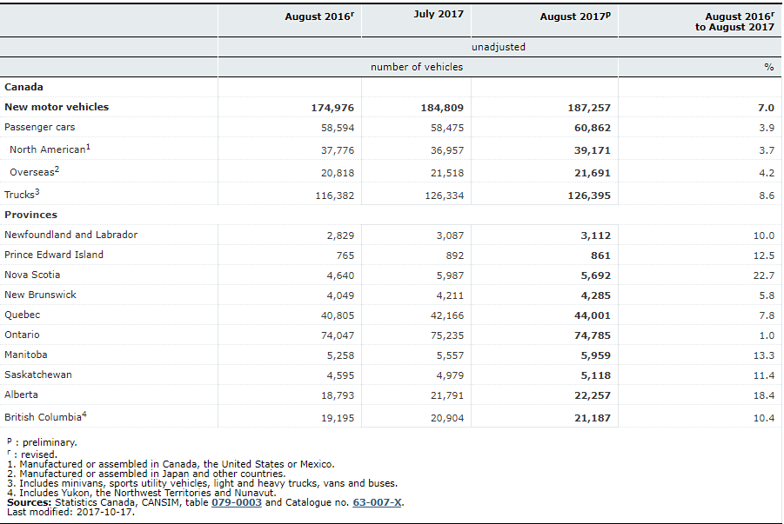 Saskatchewan provides a large amount of agricultural subsidies to farms, “The agriculture industry reaps $368 million in annual tax breaks” (Warick, 2017) so having a farm in Saskatchewan will cause even higher profit for the money laundering business. Saskatchewan is also home to many large farms which would mean the farm could generate a lot of profit and not generate suspicion from potential auditors. The Car wash would be located in Ontario due to the large amount of new vehicle sales. As can be seen in Figure 1. Ontario has the highest amount of new vehicle sales per month at 74,785 sold in August of 2017 compared to the next highest of Quebec at 44,001 sold in August of 2017 (New motor vehicle sales, by province (monthly), 2017). More vehicles means a higher profit for other car washes which means having a high profit for the front car wash would not be overly suspicious. The real estate company is in Vancouver due to the high housing prices. According to Figure 2. The average price for houses in the Vancouver area is $1,179,472 a number significantly higher than all other areas. By having surrounding homes that have an inflated value means that the real estate company can take in a significant amount of money with creating suspicion.

Figure 2 Chart depicting the housing prices of different real estate markets in Canada retrieved from (CTV News, 2017)

Figure 1 Chart depicting how many motor vehicles are sold in each province retrieved from (New motor vehicle sales, by province (monthly), 2017)

This case was inspired by the case of the Boeing 727 that was stolen from an Angolan Airport (Wright, 2010). In May of 2003 a man named Ben Charles Padilla as pictured in Figure 3 boarded a Boeing 727 and departed from the airport. Ben worked with two Angolan mechanics and a man named John 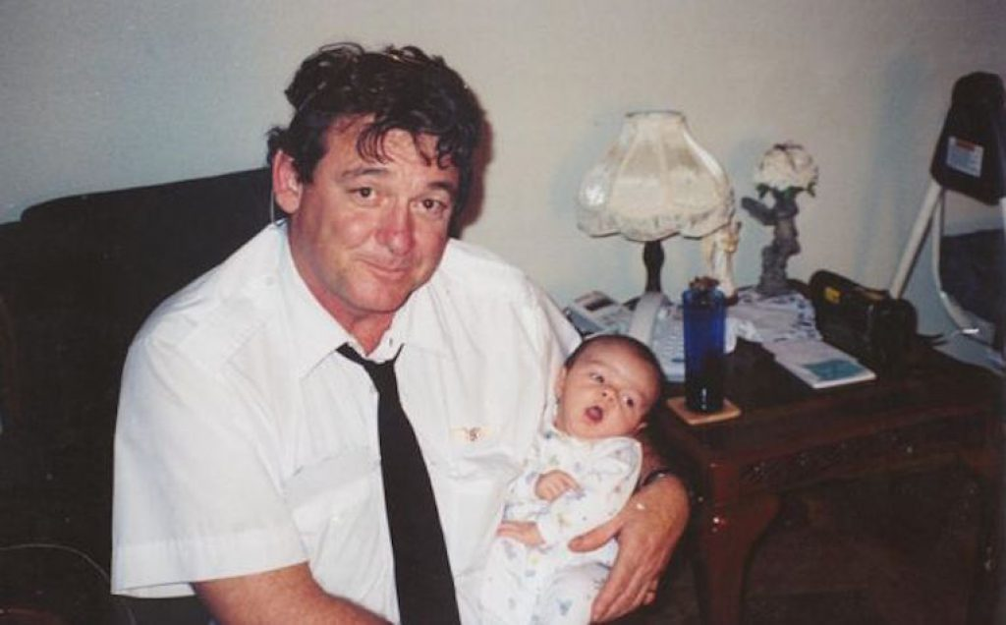Mutantu to prepare the plane for lift off, none of them had any training for flying a Boeing 727 and “A 727 ordinarily requires three trained aircrew” which none of them were (Wright, 2010). The plane most likely crash landed due to the lack of trained crew and the absence of any evidence or identification of the plane.

Figure 3 Photo of Ben Charles Padilla, one of the suspects in the disappearance of the Boeing 727 case retrieved from (Hewitt, 2016)

This planned crime with Jack, Ralph and Ahmed improved on the previous crime with Ben Padilla significantly. In Angola Ben boarded the plane in open day light, this was a huge risk, if this occurred at a more modern airport such as Pearson International, they would have been apprehended by security guards because these planes are protected by security all the time. The crime with Ben Padilla was also not foolproof, the authorities know the identities of all the aircrew, if Ben Charles Padilla were to return to a developed country he would be identified and arrested. In Ralph’s crime, he has an established alibi, Ralph had a body double head on vacation so he could claim he was not in the country when the crime occurred. Finally in the Angolan crime, no one was certified to fly a Boeing 727, in this crime Ralph is certified to fly a Boeing 747-8 and has flown them many times across the Atlantic Ocean.

The distraction of using the quadcopter is a very effective yet strange strategy. On July second of 2017 Gatwick airport in the United Kingdom was forced to shut down its runways because a drone was found flying in the airspace (Nicholls, 2017) .The runway was shut down for 14 minutes an amount of time significantly larger than the time it would take Ralph to take off since he would not have to follow proper procedure if all arrivals are cancelled (Nicholls, 2017).

There is also the concern that the government or military may shoot down the plane. Though this is highly unlikely, all external communicators will be shut down so the plane cannot be tracked or searched for this would make it incredibly difficult to discover since the airport would have little to no knowledge about the whereabouts of this plane. If the airport could track down this plane it would not be able to do anything, the plane would enter into Syrian restricted airspace and before that would most likely have flown farther than many military fighters can. Though it is unlikely that the government would even be aware that a plane is missing, this would be a very stressful event for the airport and the air traffic controllers would be focused on the protecting the safety of the passengers inside the planes attempting to land. Since the planes cannot land it will cause a severe disturbance in flight times, the airport staff will not be able to focus on the location of all planes and will rather be focusing on how to manage the schedule since most of the flights will be delayed or cancelled. This incident would distract the airport long enough so that the plane could fly away and out of the country before the authorities can be alerted and be deployed to search for this plane.

# References

CTV News. (2017, April 18). *In charts: Tracking house prices in Canada's hottest housing markets*. Retrieved from CTV News: http://www.ctvnews.ca/canada/in-charts-tracking-house-prices-in-canada-s-hottest-housing-markets-1.3373632

Hewitt, L. (2016, September 11). *The Stolen Airliner TAAG Boeing 727-223 (N844AA)*. Retrieved from Historic Mysteries: https://www.historicmysteries.com/n844aa/

*New motor vehicle sales, by province (monthly)*. (2017, October 17). Retrieved from Statistics Canada: http://www.statcan.gc.ca/tables-tableaux/sum-som/l01/cst01/econ58a-eng.htm

Nicholls, W. (2017, October 30). *This is the Chaos Caused by Flying a Drone Near an Airport*. Retrieved from PetaPixel: https://petapixel.com/2017/10/30/chaos-caused-flying-drone-near-airport/

Warick, J. (2017, March 14). *'It's a strong and vibrant industry right now': $368M farm subsidies unnecessary, says professor*. Retrieved from CBC News: http://www.cbc.ca/news/canada/saskatoon/farm-subsidies-agriculture-saskatchewan-budget-1.4018441

Wright, T. (2010, September). *The 727 that Vanished*. Retrieved from Air and Space Magazine: https://www.airspacemag.com/history-of-flight/the-727-that-vanished-2371187/